Ideation Phase
Empathize & Discover
Date | 18 June 2026
Team ID | N/A
Project Name | Book-A-Doctor Healthcare Appointment Management System
Maximum Marks | 4 Marks

Empathy Map Canvas:
An empathy map is a simple, easy-to-digest visual that captures knowledge about a user's behaviours and attitudes.
It is a useful tool that helps teams better understand their users. Creating an effective solution requires understanding the true problem and the person who is experiencing it.
For the Book-A-Doctor project, the empathy map focuses on patients who need quick access to doctors, online appointment booking, digital medical records and reliable healthcare communication.
Book-A-Doctor Empathy Map:
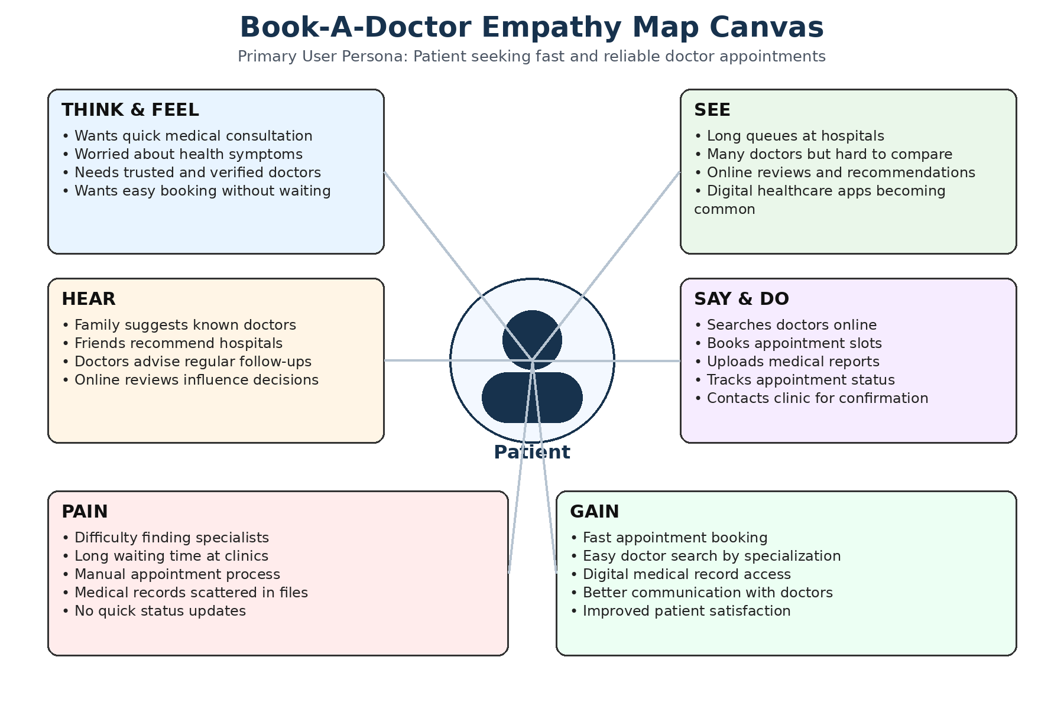
Figure 1: Patient Empathy Map for Book-A-Doctor Healthcare Appointment Management System

Example: Book-A-Doctor Healthcare Appointment Management System
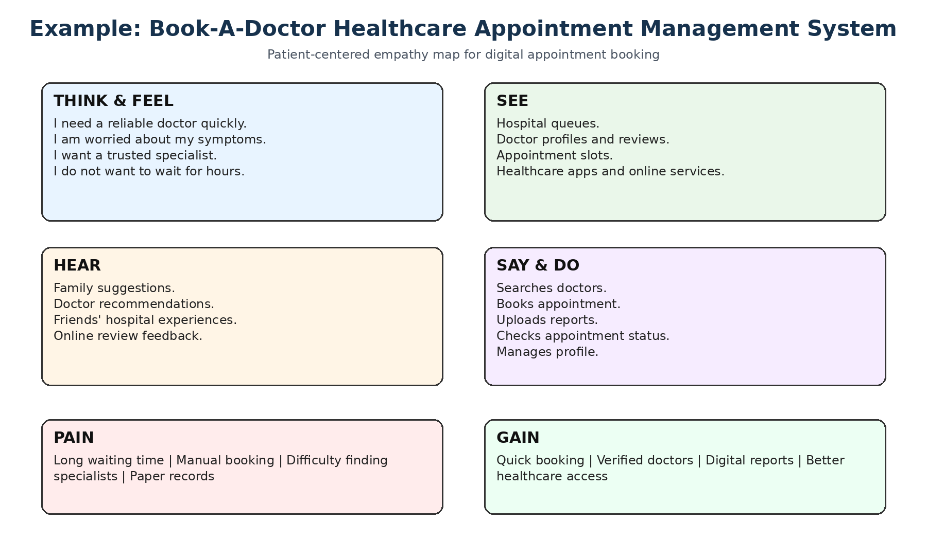
Figure 2: Healthcare Appointment Booking Empathy Map Example
References:
https://www.mural.co/templates/empathy-map-canvas
https://react.dev/
https://nodejs.org/
https://expressjs.com/
https://www.mongodb.com/docs/

